900 Washington St, Wellesley, MA 02482
617-933-4900

School and Youth Tour Informational Packet

STUDENT/YOUTH ADMISSION
- Self-Guided Garden Tours - $5 per student
- Guided Programs and Tours - $10 per student

On site educational Field Trips

Self-Guided Garden Tours

Enjoy The Gardens at Elm Bank at your own pace, groups can explore the gardens, picnic, and walk the woodland trails along the Charles River. Develop your own activities, sketch, or create a nature journal during your visit. Download and print pre-designed tour packets with fun activities designed to meet specific learning standards as you lead your students through the garden. The incredible gardens provide an excellent opportunity for meeting educational standards in a beautiful natural environment.

Guided Programs
- Discover the Charles River
  - Take a walk in any season to see what grows and lives in our native woods and waterways. Discover how we benefit from the Charles River and the importance it plays in our day to day lives.

- Seed to Flower
  - Learn the lifecycle of flowering plants with special emphasis on seeds. Topics include seed anatomy, seed dispersal methods, conditions seeds need to grow, and more. Activities incorporate seed dissection, planting a seed, observing seeds and plants in different stages of development.

- Parts of a Plant
  - Students will learn the anatomy of flowering plants and their physiological needs. Activities include pin the part on the plant, flower dissection, and potting up a small plant.

- All about Pollinators
  - Without pollinators humans would have no food. Connections will be made between the relationships of specific plants and their highly specialized pollinators. We will see the world through the lens of a bee, discover the life cycle of a butterfly, and learn about plants that support them.

- Crazy for Compost
  - One third of USA’s garbage is compostable and can be diverted from landfills. Students will go through the cycle of food scrap recycling, including what is compostable and what organisms and environmental conditions break them down into organic matter. We will review red-wriggler worms, their lifecycle, and a worm bin will be also be in attendance.

- Plants we Eat
  - Plants are in everything we eat, even processed foods. Learn the botanical difference between a fruit and a vegetable, including what flowers, seeds, and leaves people might eat. Determine the parts of the plants that show

ADULT ADMISSION
- One teacher or adult chaperone per group of 10 children is recommended and is admitted free of charge.
- Additional adults will be charged $10 each or are welcome to use their MHS membership card.
GARDEN HOURS
- The Gardens at Elm Bank is open 7 days a week, tours are welcome M-F during the hours of 9am to 4pm and Saturdays from 10am to 1pm
GENERAL TOUR INFORMATION
- Tours are scheduled to last 1.5 hours.
- Tours are designed to meet the educational standards of the students in attendance.
- Tours must be booked two or more weeks in advance of the desired tour date.
- During guided programs, guides will attempt to keep students of the same class within the same tour group, however, please be prepared to divide classes if needed.
- Shorter tour formats may be arranged upon request.

MINIMUM AND MAXIMUM PARTIPANT INFORMATION
- A minimum of 10 students are required OR $100 payment is minimum is not met.
- MHS will work to accommodate a group of any size. However, some groups may require an altered tour format to provide the best possible educational experience.
REQUESTING A TOUR
- Please note that a tour is not reserved until you receive a confirmation form via email. If you have not received a confirmation form via email within three business days of submitting your request, call (617) 933-4900. Once your request is processed, you will receive a confirmation packet via email.
PARKING AND UNLOADING
- Bus parking is available on the south east end of the parking lot, staff will pilot your bus to the correct location.
- Parking is free.
- Due to safety regulations, passengers must be unloaded in bus parking area and may not unload in the drive in front of the garden entrance
- See the “What to Expect when You Arrive” section for further details.

WHAT TO EXPECT WHEN YOU ARRIVE
Tours last 1.5 hours. When you arrive, please park and prepare to unload in the proper area(s).

If you are arriving on a yellow bus/motorcoach, due to weight limits you must enter via 4 Turtle Lane, Dover. The entrance to Turtle Lane is flanked by two large, white columns at the intersection of Main Street, Dover Road, and Charles River Street. This is not a private lane. Turtle Lane is unpaved and unmarked, and we ask that you proceed slowly. A garden staff member will be there to pilot your bus to Massachusetts Horticultural Society and The Gardens at Elm Bank. Please reference the map below.
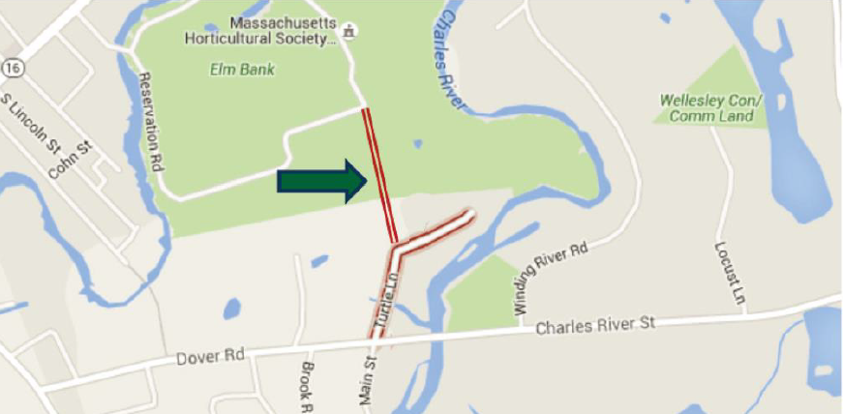

For both guided and self-guided tours, a staff member of Mass Hort will greet your group. Please note that the only restrooms available year-round are in Education Center. If your group is participating in a guided tour, the staff member and your garden guide(s) will help divide your group into smaller guided groups. Please note, that during the spring, summer and fall tours may encounter lawn care workers that could be leaf blowing, trimming, mowing, etc. throughout the garden. We apologize for any inconvenience that is caused by this regular maintenance as we work to keep the garden beautiful.

ETIQUETTE
For the enjoyment of others and the protection of the garden, we thank you for following these simple guidelines:
- Stay with your group at all times. We ask that accompanying adults do their part to ensure a safe and enjoyable trip for all participants.
- Groups may not congregate near entrances or exits to buildings as that blocks the path of other visitors
- Do not climb/walk/run on walls. For your safety, kindly stay out of garden beds and water features.
- Please avoid loud voices and noises. Let nature’s music prevail.
- Respect each other as well as other visitors. No pushing, shoving or abuse of any kind will be permitted (including verbal abuse).
- View and smell flowers, fruits, leaves and seeds, but please leave them for others to enjoy.
- Massachusetts Horticultural Society does not allow jogging, running, bicycles, sleds, skateboards, scooters, and roller blades or activities such as frisbees, footballs, kites, etc.
- Take this opportunity to cultivate the love of the beautiful garden.

APPROPRIATE DRESS ATTIRE
Programs will take place outside, please ask your students to dress appropriately for the weather. Due to the amount of walking required tennis shoes are recommended.
LUNCH AT THE GARDEN
Sack lunches may be enjoyed in the Maple Grove and Crocket Garden. There is a seating area in the Crocket garden for around 30 people otherwise the Maple Grove houses a large grass area. If you need an area to store your lunches during your trip we must be notified prior to make arrangements, otherwise lunches are to be stored on your bus/van. We currently ask that trash is packed out as we don’t have receptacles onsite.

SAFETY
Teachers and chaperones are responsible for the safety of their children. Teachers and chaperones must remain with their assigned group throughout the visit. Be especially attentive during arrival and departure when children are loading and unloading.

TEACHER AND CHAPERONE GUIDELINES

Chaperones must remain with their assigned group throughout the visit and help with supervision.

Please refrain from cell phone conversations during programs. Programs may require brisk walking.

Strollers are not permitted on a tour. Special needs guests are exempt.
- For guided tours, please note that some groups (typically around 60 or more children) may require an altered guided tour format so that the gardens can provide the best possible educational experience. If the format of the tour is altered, you will be notified before arrival.
- If attending a guided tour, please be aware that you may be asked to divide your classroom/group. The ratio of children per guide may vary depending on the type of guided tour.

INCLEMENT WEATHER AND TRANSPORTATION
All tours are entirely outdoors, indoor space is not available for groups to utilize as a replacement for an outdoor tour Transportation should be arranged in a manner that allows for tour attendees to be transported off-grounds should weather cause the tour format to be altered.

RESOURCES FOR TOURS
- Click here for a map of the gardens.

PHOTOGRAPHY CONSENT
Unless Mass Hort is notified in writing in advance about particular children or their parents (or guardian) not consenting to the children being photographed, registration serves as consent that children may be photographed and that such photos may be used in garden publications and promotional materials.

TOUR CANCELATION AND RESCHEDULING POLICY
Tours will be cancelled in severe or inclement weather; such as lightning or blizzards. In the event that your tour is cancelled due to weather, you will receive full refund for admission charges. Please do not consider your tour canceled until you have received written (electronic or paper) confirmation from the Education Department that the cancelation has been completed.
If your tour needs to be rescheduled or important information regarding your tour (such as type of tour, lunches, etc.) needs to be altered, acceptance by the gardens of the request(s) may only be considered official once you have received a new and updated confirmation receipt stating the rescheduled information. Verbal or written/typed conversation does not guarantee that the request(s) has been completed. If your tour needs to be canceled, please do not consider your tour canceled until you have received written (electronic or paper) confirmation from the Education Department that the cancelation has been completed.

To cancel or reschedule your tour, please call (617) 933-4900

PAYMENT AND REFUND POLICY
- Payments must me made one week in advance
- Payment must be made in one sum for all visitors (children and adults) involved in the tour and all related activities
- If the attendance for your group falls below the minimum level required for your tour type, guided or self-guided, the gardens reserves the right to alter or cancel your tour
- Fluctuation in the number of kids that attend your tour as a part of your group, may affect the number of chaperones that can be admitted at no charge
- No refunds are given once payment has been submitted

Payment by check should be addressed to:
Mass Hort
c/o: School/Youth Tours
900 Washington St
Wellesley MA 02482

EMERGENCY CONTACT NUMBERS

If injury is not life-threatening
- Seek the assistance of the nearest Mass Hort staff member
- If no staff member is close at hand, call the Mass Hort main number to request assistance
  - Call 617-933-4900
  - Tell the operator where you are in the garden
  - Describe the emergency
  - This step will help gardens staff to prepare for the emergency personnel

If injury is life-threatening
- Call 911
- Inform the 911 operator that you are at Massachusetts Horticultural Society, 900 Washington St
- Inform the Mass Hort main number that you have called 911

FOR FURTHER ASSISTANCE PLEASE EMAIL OR CALL Director of Programs and Education, Allison Dush adush@masshort.org or (617) 933-4900

